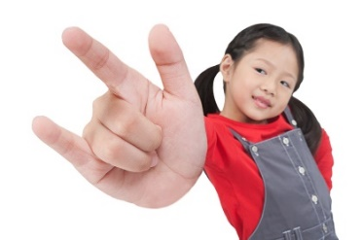
At Holly Ridge Center, we use American Sign Language (ASL) to help bridge the communication gap when young babies and toddlers are learning to communicate with spoken language. A fantastic way to support their language development is to say the word, show the sign and repeat it. It is like a sandwich of hearing the word, then seeing the sign, and hearing the word again.

In September at Holly Ridge Center, we have the theme of Going Back to School, apples, weather, and friendship, all themes we see in the fall. Below are ASL signs around these themes. Enjoy!

School:
https://www.signingsavvy.com/search/school

School Bus:
https://www.handspeak.com/word/index.php?id=6389

Apples:
https://www.handspeak.com/word/index.php?id=97

Play:
https://www.signingsavvy.com/sign/PLAY/325/1

Friends:
https://www.signingsavvy.com/sign/PLAY/325/1

Apple Tree:
https://www.youtube.com/watch?v=psnjVx5F-BQ

Fall:
https://www.signingsavvy.com/sign/FALL/561/1

Rain:
https://www.signingsavvy.com/sign/RAIN/347/1

Classroom:
https://www.signingsavvy.com/search/classroom

Teacher:
https://www.handspeak.com/word/index.php?id=2156

Contributed by Lizzie Ostag August 2022

